# ASSIGNMENT-5

## Aim and Objective:

To create a simple web service and write any distributed application to consume the web service.

## Tools/Environment:

Java Programming Environment, JDK8, EclipseIDE with Tomcat Server

## Calculator.java

packagecom;

publicclassCalculator{

publicint add(inta,int b)

{

returna+b;

}

publicint sub(inta,int b)

{

returna-b;

}

publicint mult(inta,int b)

{

returna+b;

}

publicint div(inta,int b)

{

returna+b;

}

}

# Outputs

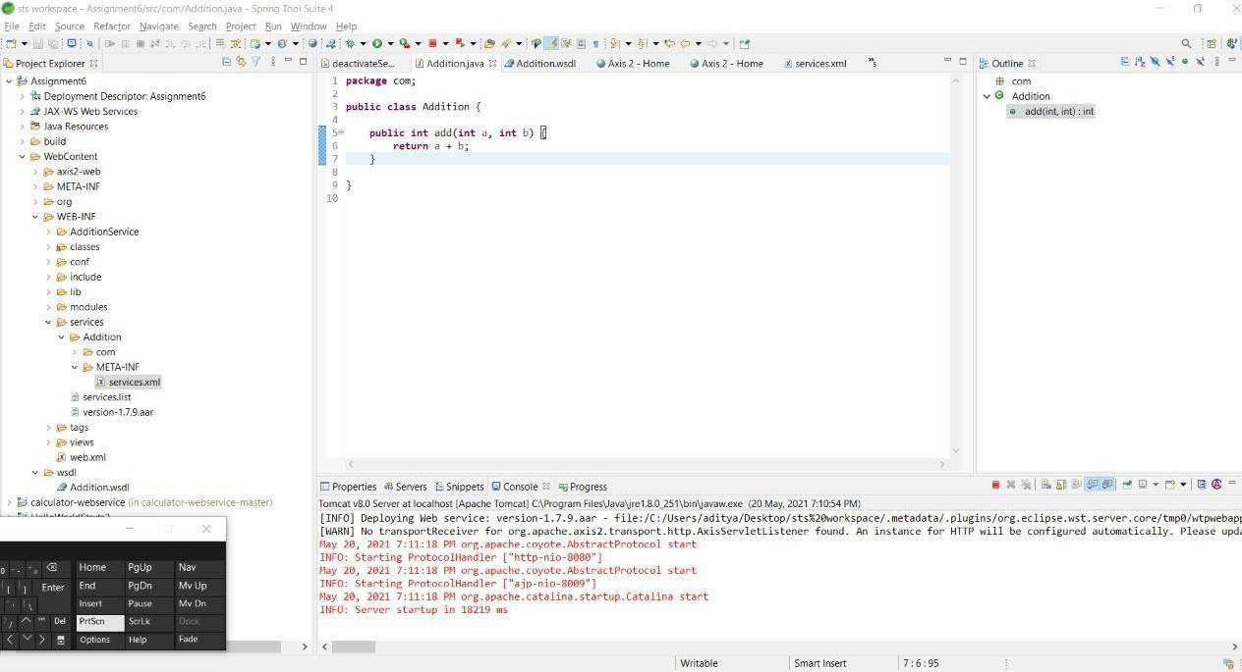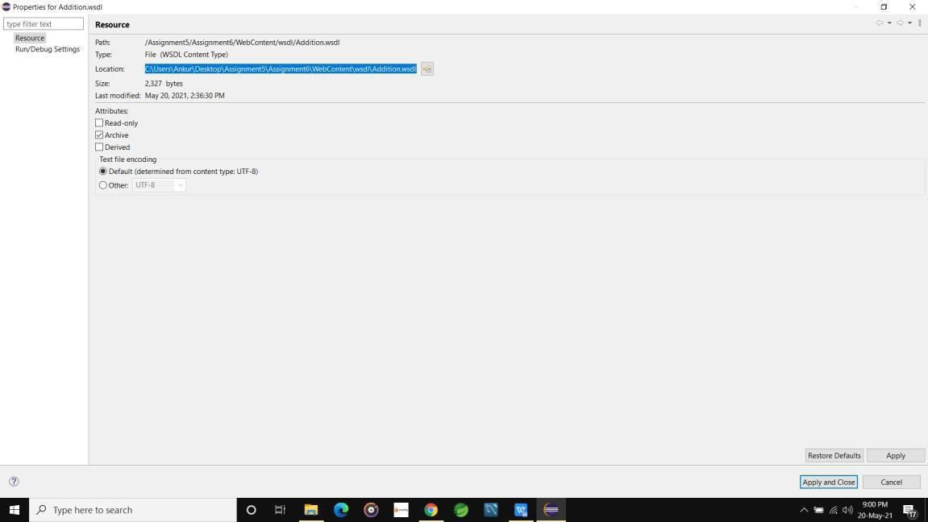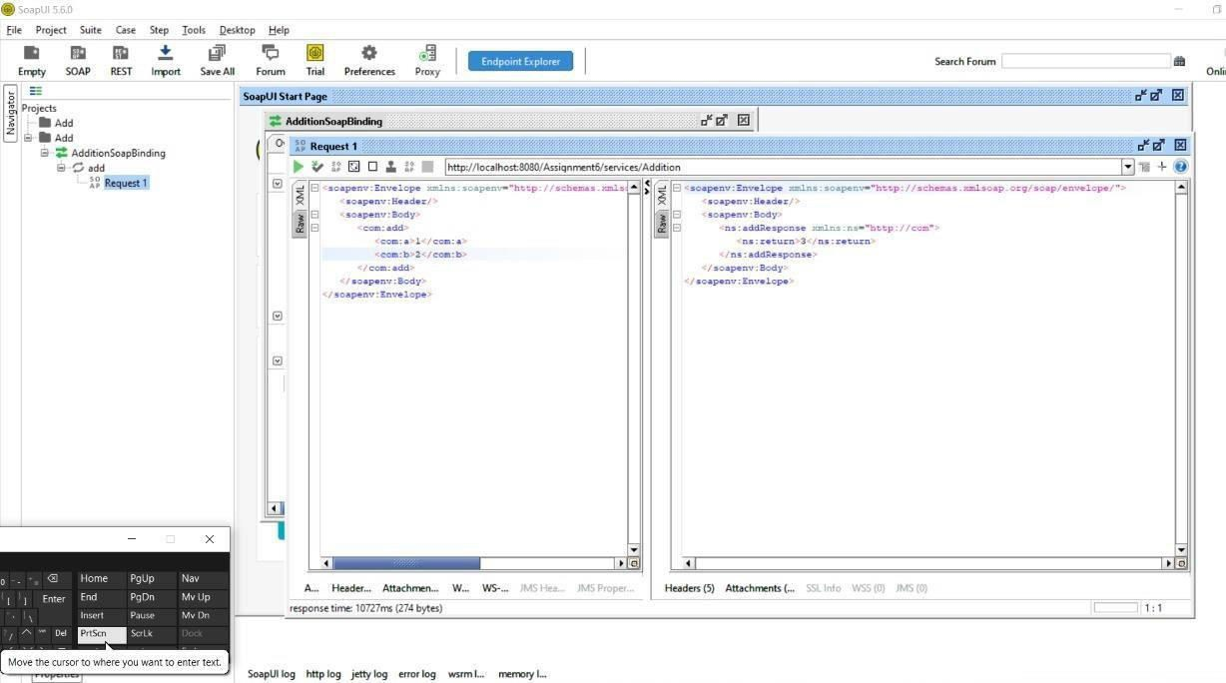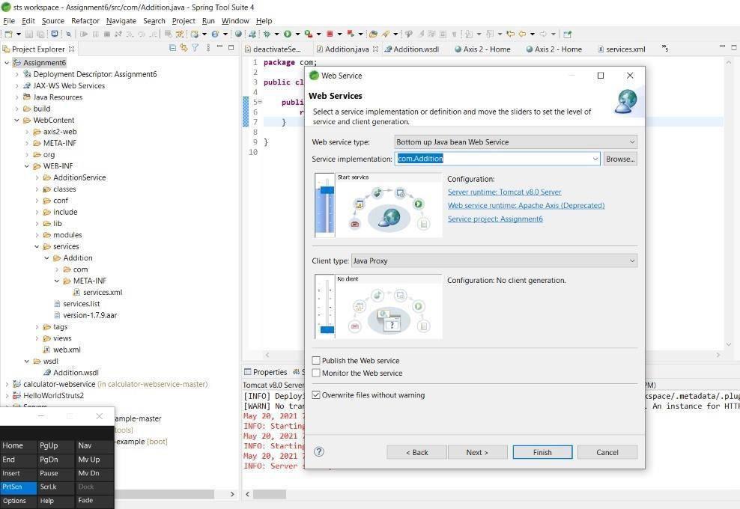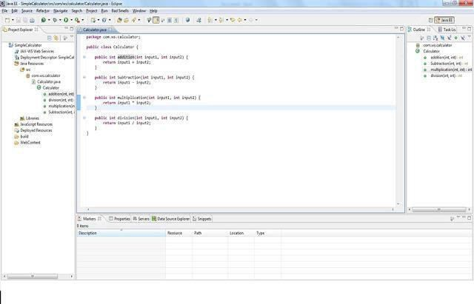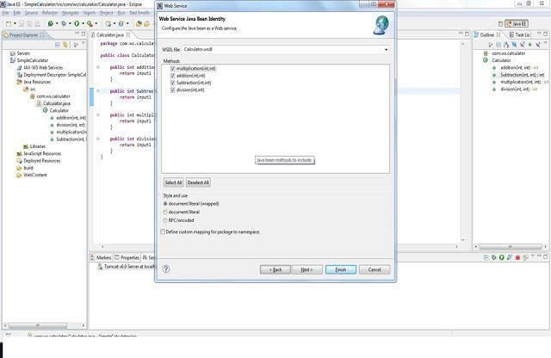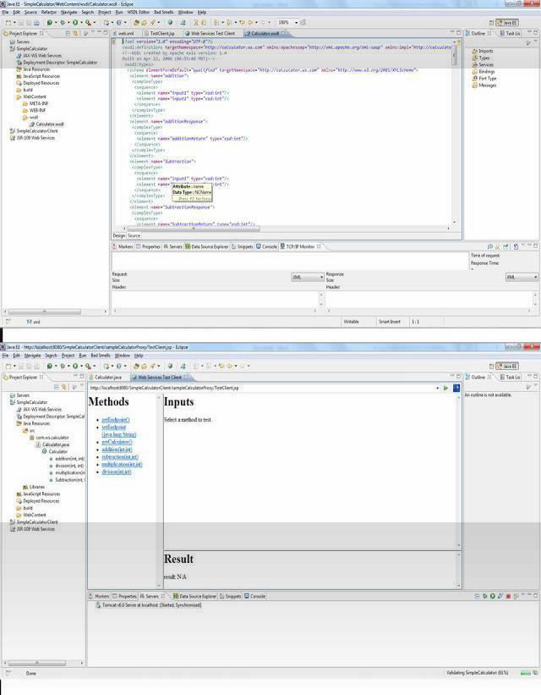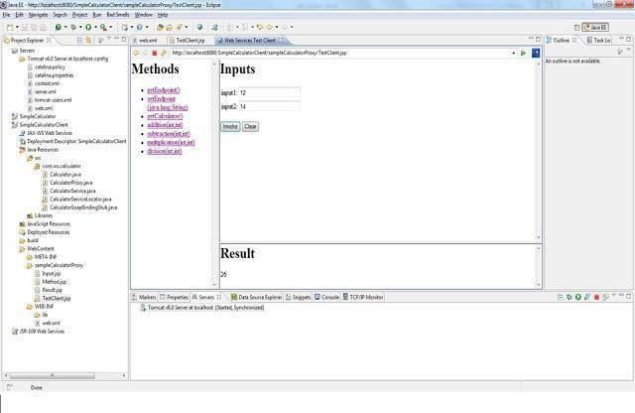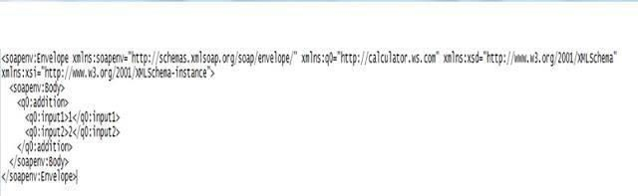

1. Addthefollowingcodetoindex.jspindex.jspsolid<%@pageimport="java.net.UR L,javax.xml.namespace.QName,javax.xml.ws.Service,org

.apache.geronimo.samples.jws.Calculator"%><htmlxmlns="<http://www.w3.org/1999/xhtml>"xml:lang="en">

<head><title>Calculator</title></head><body><formaction="result.jsp">Pleaseenter2wholenumberstoadd:<i nputtype="text"name="value1">+<inputtype="text"name="value2"><inputtype="submit"value="="></form>

</body></html>

1. RightClickontheWebContentfolderandSelect**New->JSP.**
2. Namethejspasresult.jsp andSelect**Finish.**

Add the following code to jsp. result.jspsolid<%@pageimport"java.net.URL,javax.xml.namespace.QName,jav ax.xml.ws.Service,org

.apache.geronimo.samples.jws.Calculator"%><htmlxmlns="[http://www.w3.or](http://www.w3.or/) g/1999/xhtml"xml:lang="en"><head>

<title>Calculator Result

</title>

</head>

<%intvalue1=0;intvalue2=0;intsum= 0;try{System.out.println(request.getParameter( "value1")

+""+request.getParameter("value2"));value1=Integer.parseInt( request.getParameter( "value1"));value2=Integer.parseInt(request.getParameter("value2"));URLurl=n ewURL("http://localhost:8080/jaxws-calculator- 1.0/calculator?wsdl");QNameqname=newQName("[http://jws.samples.geroni](http://jws.samples.geroni/) mo.apache.org","Calculator");Serviceservice=Service.create(url,qname);Calcul atorcalc

=(Calculator)service.getPort(Calculator.class);sum=calc.add(value1,value2);}ca tch(Exceptione){e.printStackTrace();}%>

<body>Theresultis:<%=value1%>+<%=value2%>=<%=sum%><br><ahref

="index.jsp">Back</a></body></html>Thisfinishes thedevelopmentofWeb client.

ExpandWEB-INF/web.xmlandaddthefollowingcodeweb.xmlsolid

<?xmlversion="1.0"encoding="UTF-8"?>

<web-appxmlns:calc="urn:geronimo-samples- jws"xmlns="<http://java.sun.com/xml/ns/javaee>"version="2.5">

<servlet>

<display- name>CalculatorService

</display-name>

<servlet-

name>CalculatorService

</servlet-name>

<servlet- class>org.apache.geronimo.samples.jws.CalculatorService

</servlet-class>

</servlet>

<servlet-mapping>

<servlet- name>CalculatorService

</servlet-name>

<url-pattern>

/calculator

</url-pattern>

</servlet-mapping>

<service-ref>

<service-ref- name>services/Calculator</service-ref- name>

<service-interface>javax.xml.ws.Service</service-interface>

<wsdl-file>WEB-INF/CalculatorService.wsdl</wsdl-file></service-ref>

</web-app>

1. Similarlydoubleclickgeronimo-web.xmlandaddthefollowing code.geronimo-web.xmlsolid<?xmlversion="1.0"encoding="UTF-8"?>

<web-app xmlns="<http://geronimo.apache.org/xml/ns/j2ee/web-1.1>">

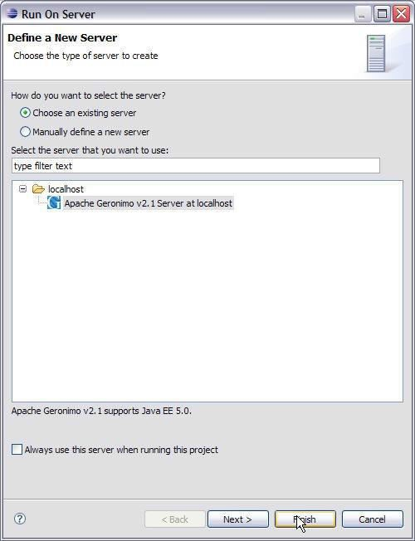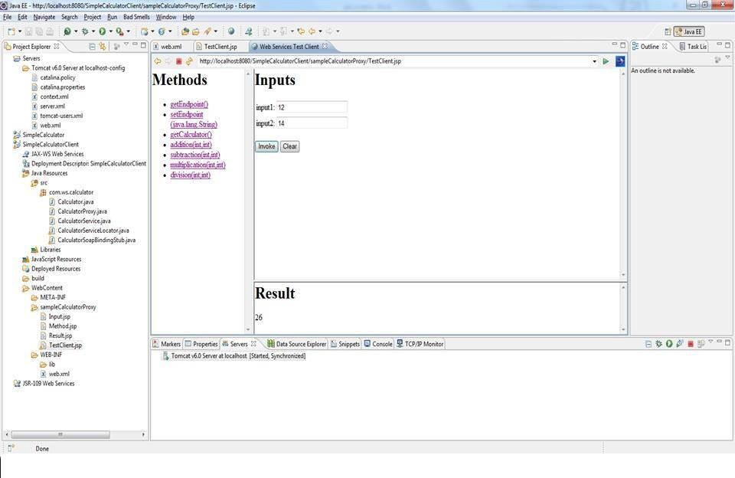

packagecom.webServices;

publicclassCalculator {

publicintadd(inta,intb){return(a+b)

;

}

publicintsubtract(inta,intb){return (a-b);

}

publicintmultiply(inta,intb){return (a*b);

}

publicintdivide(inta,intb){return(a

/b);

}

}

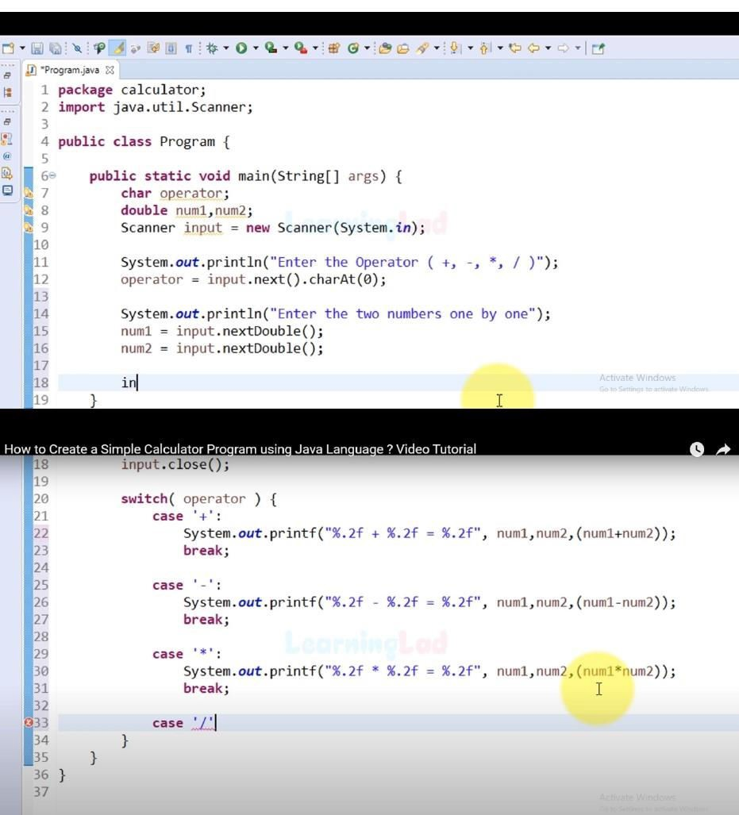

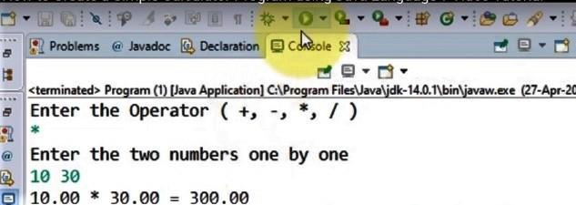

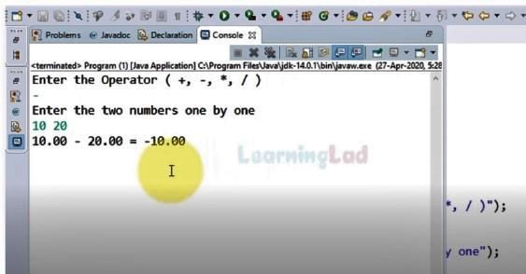

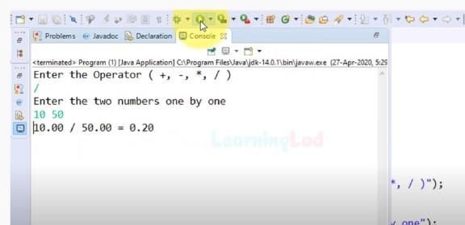

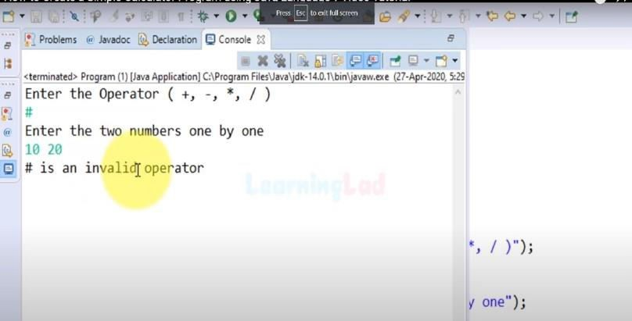

## Theory: WebService:

A web service can be defined as a collection of open protocols and standards for exchanging information among systems or applications.

A service can be treated as a web service if:

* + The service is discoverable through a simple lookup
  + It uses a standard XML format for messaging
  + It is available across internet/intranet networks.
  + It is a self-describing service through a simple XML syntax
  + The service is open to, and not tied to, any operating system/programming language

## Types ofWebServices:

There are two types of web services:

1. **SOAP**: SOAP stands for Simple Object Access Protocol. SOAP is an XML based industry standard protocol for designing and developing web services. Since it**’**s XML based, it**’**s platform and language independent. So, our server can be based on JAVA and client can be on .NET, PHP etc. and vice- versa.
2. **REST**: REST(Representational State Transfer) is an architectural style for developing web services. It**’**s getting popularity recently because it has small learning curve when compared to SOAP. Resources are core concepts of Restful web services and they are uniquely identified by their URIs.

## Web service architectures:

As part of a web service architecture, there exist three major roles.

**Service Provider** is the program that implements the service agreed for the web service and exposes the service over the internet/intranet for other applications to interact with.

**Service Requestor** is the program that interacts with the webservice exposed by the Service Provider. It

Makes an invocation to the web service over the network to the Service Provider and exchanges information.

**Service Registry** acts as the directory to store references to the web services

The following are the steps involved in a basic SOAP web service operational behavior:

1. The client program that wants to interact with another application prepares its request content as a SOAP message.
2. Then, the client programs ends this SOAP message to the server web service as an HTTP POST request with the content passed as the body of the request.
3. The web service plays a crucial role in this step by understanding the SOAP request and converting it into a set of instructions that the server program can understand.
4. The server program processes the request content as programmed and prepares the output as the response to the SOAP request.
5. Then, the web service takes this response content as a SOAP message and reverts to the SOAP HTTP request invoked by the client program with this response.
6. The client program web service reads the SOAP response message to receive the outcome of the server program for the request content it sent as a request.

## SOAP web services:

**Simple Object Access Protocol**(**SOAP**) is an XML- based protocol for accessing web

services. It is a W3C recommendation for communication

between two applications, and it is a platform-and

language- independent technology in integrated distributed applications.

While XML and HTTP to gether make the basic platform for webservices, the following are the key components of standard SOAP web services:

**Universal Description, Discovery, and Integration**(**UDDI**)*:*UDDI is an XML based frame work for describing, discovering ,and integrating web services. It acts as a directory of web service interfaces described in the WSDL language.

**Web Services Description Language**(**WSDL**)*:*

WSDL is an XML document containing information about web services, such as the method name, method parameters, and how to invoke the service. WSDL is part of the UDDI registry. It acts as an interface between applications that want to interact based on web services.

## Conclusion:

This assignment, described the Web services approach to the Service Oriented Architecture concept. Also, described the Java APIs for programming Web services and demonstrated examples of their use by providing detailed step-by- step examples of how to program Web services in Java.